 | 
Attendance Policy (Pupils) | ULT is committed to providing a supportive framework to pupils and their families where a shortfall in attendance has been identified to assist pupils to improve, reach and maintain the standard of attendance and punctuality expected. This policy outlines our procedures and ensures we adhere to the new 2024 National Framework and Working together to improve attendance guidance.

This policy was approved as follows:
Approver: | CEO | Date: | June 2024
Adopted: | LGB | Date:
ULT owner: | CEO | Version: | V1.0
Review frequency: | Annually | Next review date: | June 2025
Status: | Statutory
Version | Version Date | Author | Summary of Changes
V0.1 draft | 06/06/24 | Operations | Draft Attendance Policy written in consultation with VIA Education Welfare Officer
V1.0 | 11/06/24 | Operations | Policy reviewed and approved by the CEO
V1.0 | 12/06/24 | Operations | Sent out to schools

Document History

Contents
1. Introduction 1
2. Objectives 1
3. Attendance Expectations 2
4. Parent/Carer and Pupil expectations 2
5. Registration Procedures 3
6. Pupil absence 4
7. Reporting Absence 5
8. Leave of Absence 5
9. Non return from Leave of Absence 5
10. Monitoring Attendance and Punctuality 7
11. Children Missing in Education 7
12. Supporting Pupils with Medical Conditions/SEND 8
13. Rewarding good attendance 9
14. Elective Home Education 9
15. Collaborative Approach with Local Partners 9
16. Evaluating Effectiveness 9
17. Reporting to Governors 10
Appendix 1 – Attendance equates to Poster 11
Appendix 2 – Should I keep my child off school? 12
Appendix 3 – Every Minute Counts Poster 13
Appendix 4 – Leave of absence request letter template – NOT authorised 14

Introduction
At Uttoxeter Learning Trust our Schools are committed to working together to ensure all pupils receive the best education possible and to enable them to achieve to the best of their ability. For this to happen, pupils need to be in school to access valuable teaching and learning opportunities.
This policy aims to make clear what is expected of parents and pupils and to assure parents of our willingness to collaborate positively with them if problems arise.
The law on school attendance and right to full-time education
The law entitles every child of compulsory school age to an efficient, full-time education suitable to their age, aptitude, and any special educational need they may have. It is the legal responsibility of every parent to make sure their child receives that education either by attendance at a school or by education otherwise than at a school. Where parents decide to have their child registered at school, they have an additional legal duty to ensure their child attends that school regularly. This means their child must attend every day that the school is open, except in a small number of allowable circumstances such as being too ill to attend or being given permission for an absence in advance from the school.

Objectives
To raise the overall school attendance to be at least in line with national data and to improve attendance to above the national average.
- To reduce the number of persistent absentees.
- To promote a culture of punctuality and good attendance.
- To improve parental understanding of the school’s expectations and for attendance and punctuality.
- To work with the Local Authority officers, to improve pupil attendance and punctuality.
- To closely monitor attendance and punctuality.

These will be achieved by:
- Analysing attendance data to identify trends and patterns.
- Use benchmarking against national averages to set realistic targets.
- Implement targeted interventions for pupils with low attendance.
- Regularly communicate with parents about attendance expectations.
- Provide clear information on the importance of attendance and punctuality.
- Encourage parental involvement in school activities.
- Foster a sense of belonging and community.
- Celebrate good attendance and punctuality.
- Educate students about the impact of attendance on their learning.
- Work closely with Local Authority officers to address attendance issues.
- Seek their support in implementing effective strategies.
- Adjust interventions as needed based on data and feedback.

Attendance Expectations
All pupils are expected to achieve a minimum of 96% attendance. Appendix 1: Attendance Poster, will be displayed in schools and shared with parents via the school website to raise awareness of the impact of missed school days as outlined in the table below:
Impact of absence:

Missed number of days | Missed number of sessions | Missed the number of weeks | Missed several lessons
1 | 2 | 0 | 5
3 | 6 | 0.5 | 15
5 | 10 | 1 | 25
7.5 | 15 | 1.5 | 35
10 | 20 | 2 | 50
12.5 | 25 | 2.5 | 65
15 | 30 | 3 | 75
17.5 | 35 | 3.5 | 90

Impact of lateness over a school year:
5 minutes late every day = 3 days absence

15 minutes late every day = 10 days absence

30 minutes late every day =19 days absence

At All Saints CE First School we value achievement of every kind and believe that we all respond well to having high expectations placed upon us. These expectations cannot be met if students do not attend regularly or are persistently late. School seeks to be proactive when dealing with attendance issues, as students have the right to a quality education and to learn without disruption. Students also have the responsibility to be punctual to school/lessons and consistently demonstrate respect to staff and students in their lessons.

Parent/Carer and Pupil expectations
Parents/carers are expected to:
- Contact school daily, if their child is absent from school for any unavoidable reason such as sickness. Parents should contact the school as soon as possible, on the first morning of absence. This may be done by phone, email, through the school text system, by letter or in person.
- Not let their children take time off school for minor ailments, particularly those which would not prevent them from going to work e.g. headache, period pains, sore throat, cough and colds.
- Ensure their children understand the importance of good attendance and punctuality and the links between good attendance and good attainment.
- Avoid making medical/dental appointments for their children during school hours.
- Ensure that their child arrives every day and on time to school, by 8.45am every morning.
- Not book family holidays during term time. The school reserves the right to request that the Local Authority issue a penalty notice in such cases.
- Discuss any problems they may have at school and let their teacher or Head of Year know about anything serious or where you feel we can support them.

Family contact details:

To allow us to safeguard children, parents/carers must provide the school office with their current contact details and provide at least two, and preferably three, other contact numbers of trusted adults in case of emergency where possible.

Pupils are expected to:
- Ensure that they attend school regularly.
- Ensure they follow school policies and procedures.
- Ensure that they attend school on time.
- Have their attendance and punctuality acknowledged by the school.
Attendance Team – Contact details

Name | Role | Contact Information
Lesley Flannagan | Attendance Champion | Tel: 01889 502289  Email:office@allsaints-leigh.staffs.sch.uk
Andrea Cairns | Attendance Champion (DSL) | Tel: 01889 502289  Email:headteacher@allsaints-leigh.staffs.sch.uk
Karl Hobson | Head of Attendance & Inclusion  Children & Families Staffordshire | Tel:  Email:karl.hobson@staffordshire.gov.uk
VIP Education | EWO Service | Tel: 01782 367219  Email: contact@vipeducation.co.uk/info@vipeducation.co.uk

Registration Procedures

School is obligated to maintain an attendance register twice daily—once in the morning and again at the start of the afternoon session. This register serves to record whether a pupil is present, engaged in an approved educational activity off-site, or absent. In the event of absence, each half-day must be categorised by the school as either authorised or unauthorised. Importantly, only the school has the authority to authorise absences; parental authorisation is not sufficient. Consequently, comprehensive information regarding the cause of each absence remains essential.

School opens at 8.45am and closes at 3.15pm

When completing the register, schools follow the DFE Working together to improve school attendance guidance to determine which relevant code to use (Chapters 7 & 8);
Working together to improve school attendance (applies from 19 August 2024) (publishing.service.gov.uk)

Morning registration.
Registers are open for 30 minutes from the start of the school day.
The morning register is taken at 8.55am, pupils arriving after the register has been taken but before 9.25am are recorded as late – L code.
Registration closes at 9.25am pupils arriving at school after this time are late as registration has closed, and this will be recorded as an unauthorised absence – U code.
Afternoon registration
The afternoon register is taken at 1.00pm pupils arriving after the register has been taken but before 1.30pm are recorded as late – L.
Registration closes at 1.30pm, pupils arriving at school after this time are late and this will be recorded as an unauthorised absence – U.
Late procedures
Parents are requested to contact the school by 9.20am via telephone, 01889 502289, and leave a message which includes the pupil’s name, class or form group and provide a reason for lateness with a time as to when to expect them to arrive, or email the school: office@allsaints-leigh.staffs.sch.uk
If persistent lateness (defined as accumulating four or more late marks) remains a concern, the following procedures will be implemented:
- Parents will receive a letter informing them of the concern.
- If there is no improvement, the Education Welfare Officer (EWO) from VIP Education will contact parents to further discuss and offer support and advice to help improve punctuality.
- If there is still no improvement, parents and pupils will be invited to a meeting with the EWO to discuss the reasons for lateness and to offer further support. Referrals to wider support services may be offered if needed. The discussion held will be documented by the EWO and an action plan to improve punctuality will be devised with parents and the pupil during the meeting with a review date set if needed.
- If no improvement is seen after the meeting has taken place, the school may follow Staffordshire Local Authority’s Code of Conduct for issuing penalty notices for persistent lateness.

Pupil absence
Authorised absence is an absence for sickness for which the school has granted leave:
- Consultants’ appointment which unavoidably falls during the school day of which the school has received an appointment card or hospital letter. However, the expectation is that students should attend school before or after any appointment.
- Religious observations for which the school has granted leave.
- Family emergency in which the school has granted leave.
- An agreed request for Leave of Absence under exceptional circumstances.

An unauthorised absence is:
- Parents/carers keeping their children off school unnecessarily or without good reason.
- Truancy before or during the school day.
- Absences that have not been properly explained and the school has not granted leave.
- Medical evidence has not been provided.
- Arriving late to school after registers have closed or when the late privilege has been removed.
- Unauthorised leave of absence during term time.
- Attendance below 90%, where medical evidence has not been provided.

Parents should endeavour to ensure that their child attends school wherever possible. Appendix 2 Should I Keep my child off school poster, supports parents when having to decide as to whether their child should be attending school.

Reporting Absence
If a pupil is absent from school, we ask parents to:
- Contact the school office by phone by 9.20am on the first morning of absence and leave a message which includes the pupil’s name, class or form group and provide a reason for absence.
- Reply promptly to any request or enquiry concerning an absence.

If parents do not contact the school on the morning of the first day of absence, a member of the administration or pupil welfare staff will try to contact them to find out the reason for the absence. This ensures that the parent is aware their child is not in school enabling the parent, where necessary, to establish that their child is safe. A Designated Safeguarding Lead will be informed to ensure that there are no known underlying safeguarding concerns that the school is aware of and may then require a more immediate response via a home visit/ social care/police contact.

The school may also ask the EWO to establish contact either by telephone, text message or a home visit may be completed. If a reason is still not known after 3 school days, the absence will be unauthorised and safeguarding procedures will be implemented and a home visit will be conducted.

Leave of Absence

The Department for Education (DfE) maintains that a child’s attendance during the 39 weeks of the academic year is crucial, and holidays during term time—regardless of their nature—are not considered ‘exceptional’ circumstances. Taking a child or young person out of school solely for a holiday is not deemed a valid reason.

Leave of absence is granted by the Headteacher and Governing Board only in truly exceptional circumstances. Such absences differ from term-time holidays and may include situations like bereavement, serious illness, or significant cultural or religious events.

Furthermore, any request for holiday leave must be submitted at least four weeks before the intended absence."

Non return from Leave of Absence

It may occur that a child does not return within the stated period of leave of absence. Initially, normal school absence procedures are followed.

If the child has not returned within three days after the stated period of leave of absence, the following procedure is followed:
· Case referred to the EWO and safeguarding team.
· Home visit carried out by school and/ or EWO.
· A referral may be made to the local authority and/or police.
Legal Sanctions:

Both the school and local authority have the authority to levy fines upon parents for their child’s unauthorised absence from school. The decision to issue a penalty notice rests with either the headteacher, a local authority officer, or the police.

Any unauthorised absence may prompt a referral to the local authority, potentially resulting in the issuance of a penalty notice in accordance with the ‘Working Together to Improve School Attendance’ guidelines.
Within a 3-year rolling period:
First penalty notice: £160 (if paid within 28 days) or reduced to £80 (if paid within 21 days).
Second penalty notice: Flat rate of £160 (if paid within 28 days).
No Third Penalty Notice:

A third penalty notice cannot be issued to the same parent for the same child within 3 years of the date of the first notice.

If the national threshold is met for a third time within those 3 years, alternative actions (such as prosecution or other attendance legal interventions) will be considered.

In line with the National Framework, the Local Authority retains the discretion to issue a Penalty Notice before the threshold is met. For example, when parents/carers are deliberately avoiding the national threshold by taking multiple term time holidays below threshold, or for repeated absence for birthdays or other family events, or a combination of non-attendance due to leave of absence and unauthorised absence.

Unauthorised Absence Penalty Notices can be requested by schools when there have been 10 sessions of unauthorised absence in a 10-week period. In these circumstances a Notice to Improve may be sent by the Local Authority on behalf of the school, this will stipulate the support that has already been implemented and the ongoing support that is available to the parent and child to improve school attendance. The Notice to Improve will also detail the expected improvements that must be made over a set time frame to prevent the Penalty Notice from being issued. Further information on the National Framework can be found within Working Together to Improve Attendance 2024. The National Framework comes into effect on 19th August 2024. Working together to improve school attendance (applies from 19 August 2024) (publishing.service.gov.uk)

A penalty notice may also be issued where parents allow their child to be present in a public place during school hours without reasonable justification during the first 5 days of a fixed period or permanent exclusion. The school will notify the parents of the days the pupil must not be present in a public place. This type of penalty notice is not included in the National Framework and therefore not subject to the same considerations linked to support being provided or as part of the escalation process in the case of repeat offences for non-attendance.

Monitoring Attendance and Punctuality

The school will regularly analyse attendance data to identify patterns of absence, both at the individual student level and across the whole school. This analysis will allow for early intervention and targeted support measures to be implemented for students with emerging attendance issues.

Specific methods may include:

- Running weekly/monthly reports to flag students with concerning absence rates
- Examining attendance by grade level, demographic group, or other factors to pinpoint areas of concern
- Tracking and responding to consecutive absences or patterns like absences on specific days
- A letter is sent to parents informing them of a decline in school attendance and the need for this to improve due to the impact on their child’s education and social development.
- If no improvement is seen, parents and pupils, where appropriate, will be invited into a meeting with the Education Welfare Officer and school attendance officer to discuss the concerns and to offer support around any possible barriers, or problems at home or at school which may be contributing to low attendance. Referrals to wider support services may be offered where appropriate. The discussion held will be documented by the EWO and an action plan to improve school attendance will be devised during the meeting and a review date set if needed.
- If school attendance does not improve, the school may follow the Staffordshire County Council ‘s Code of Conduct for issuing penalty notices for pupils with persistent absence.

Children Missing in Education

Children who go missing from education are at significant risk of underachieving, and becoming victims of harm, exploitation, radicalisation or serious violence and/or becoming NEET (not in education, employment or training).

Children who are already known to children’s social care, who are on a child in need or child protection plan or in the care of the local authority are additionally vulnerable and in need of robust protection.

Where a child has not returned to School for ten days after an authorised absence or is absent from School without authorisation for twenty consecutive school days the school may remove the student from the admissions register if the following two conditions are met:

The school and local authority have jointly made reasonable enquiries to try to locate the student, following the steps outlined below, but have failed to establish the child's whereabouts.

The school does not have reasonable grounds to believe the student is unable to attend due to sickness or other unavoidable causes.

Before removing a child from the register, the school will make reasonable enquiries with the local authority to ascertain the whereabouts of the child which could include:

Contacting the parent, relatives, and neighbours, using known contact details.

Checking with agencies known to be involved with family.

Checking with the local authority and school from which the child moved originally if known.

Checking with any local authority and school to which a child may have moved to.

Checking with the local authority where the child lives, if different from the Academy’s location.

Making home visit(s), if appropriate. All home visits will be risk-assessed before being carried out.

The school will consult with the local authority CME officer throughout this process and provide documentation of all enquiries made. Only once all reasonable efforts are exhausted will removal from the register be approved.

Supporting Pupils with Medical Conditions/SEND

The school is unwavering in its commitment to creating a nurturing and inclusive environment for all students, with a particular focus on those whose attendance may be impacted by medical conditions or special educational needs and disabilities (SEND). To achieve this, the school has proactively instituted a comprehensive set of measures. These measures include:
- Development of individualised healthcare and support plans for students with chronic or ongoing medical needs.
- Facilitating access to the school nurse, counselling, or other therapeutic services as needed.
- Coordinating with parents/carers and external providers to ensure continuity of learning during absences.
- Considering flexible attendance arrangements, part-time schedules, or home instruction when appropriate.

By implementing these strategies, the school ensures that every student has the opportunity to thrive both academically and socially. Making reasonable adjustments and accommodations to the school environment and curriculum access.

Appointments:

School requests for dental and medical appointments are made outside of school hours as these absences have an impact on your child’s attendance and, thus their attainment. If a medical appointment is made during school time, the school will expect the student to attend before or after the appointment, where possible. These students will have to be signed in and out of school by our Attendance Officer. The Attendance Officer will require proof of the appointment before any appointment is authorised - this can be an appointment card or letter provided before this absence is authorised.

Rewarding good attendance
At All Saints School we have a weekly attendance award for the class with the best attendance, the class winners receive a certificate and a trophy which they can display in their classroom for the week. This is presented in the weekly celebration assembly. Certificates are awarded at the end of the academic year for those children with attendance of 100%, 99% and 98%.

Elective Home Education

If the school receives written notification from parents that they wish to home-educate their child, the school will contact the parent and discuss their reasons in more detail, offering support to deal with any issues raised. If after this time the parent still wishes to home-educate their child, the school will inform the Local Authority of the decision to remove the child’s name from the admissions register. Although home education is the right of the parents the school have the right to disagree with home education.

Whilst school will not seek to prevent parents from choosing to home-educate their child, neither will they seek to encourage them to do this – particularly as a way of avoiding exclusion or due to a poor attendance record. Before deciding to home educate, parents are requested to contact the Staffordshire Local Authority Elective Home Education department. Elective home education - Home - Staffordshire County Council

Collaborative Approach with Local Partners
The school recognises that strong partnerships across local services are essential for supporting attendance and removing barriers. As such, the school will:
- Develop relationships and communication pathways with local authority early help services, social care, health providers, and police.
- Establish procedures for making referrals to appropriate services when additional support is needed for the student or family.
- Participate in multi-agency meetings to coordinate a holistic plan for students facing complex challenges.
- Work with partners to understand and address root causes like poverty, mental health, and community issues impacting attendance.
- Collaborate on truancy sweeps, home visits, or other engagement initiatives in the community.

Evaluating Effectiveness
In addition to identifying areas for intervention, attendance data will be utilised to evaluate the effectiveness of strategies and initiatives aimed at improving attendance rates. This will involve:
- Comparing attendance metrics before and after implementation of new approaches
- Surveying students, parents, and staff on the perceived impact of attendance efforts
- Continuously refining and adapting strategies based on their measured outcomes

Reporting to Governors
To ensure transparency and accountability, the school leadership will provide regular attendance reports and updates to the governing board. These reports may include:
- Overall attendance rates for the school and breakdown by grade levels
- Progress towards annual attendance goals and targets
- Updates on the implementation and effectiveness of specific attendance initiatives
- Identification of persistent issues or areas requiring additional governance support

Appendix 1 – Attendance equates to Poster
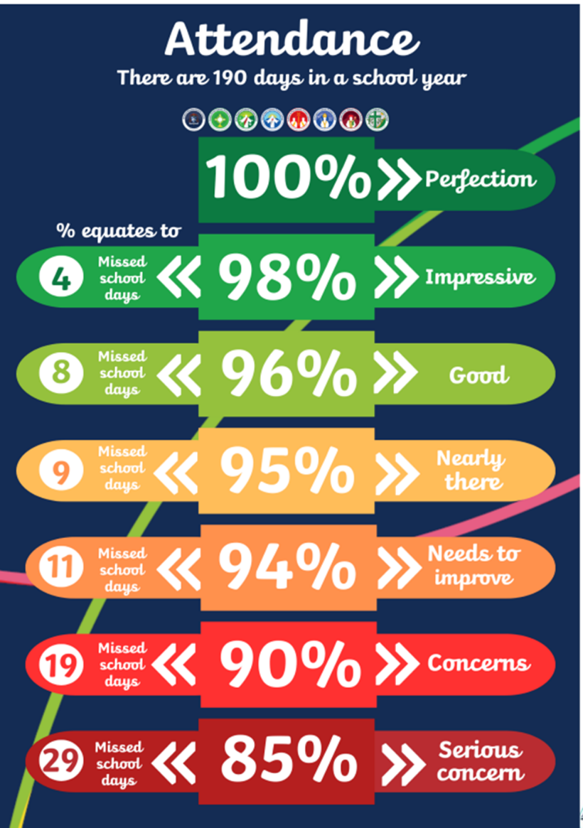

Appendix 2 – Should I keep my child off school?
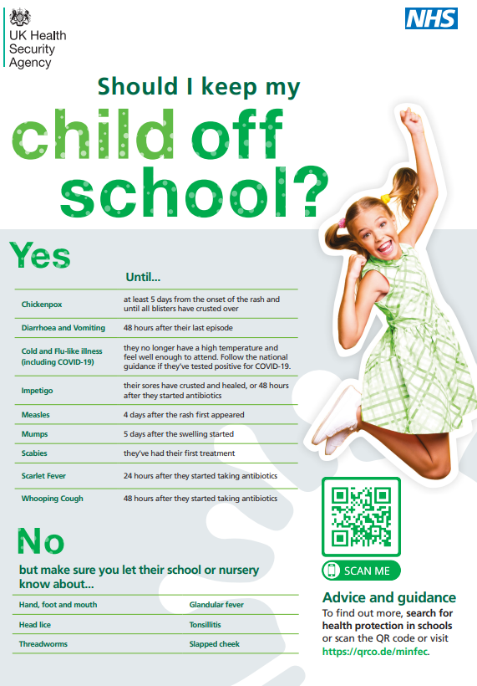

Appendix 3 – Every Minute Counts Poster


Appendix 4 – Leave of absence request letter template – NOT authorised
Date:
Dear (send to both parents)
Re: Leave of absence request for (insert pupil(s) name here)
Thank you for your recent leave of absence request from: - …………. To………….
You will be aware that the Department of Education made important changes to the law for families wanting to request a leave of absence in term time. The changes made it clear that head teachers may not grant any leave of absence during term time unless there are exceptional circumstances. The Local Authority and school governors support this; therefore, students will only be permitted to take leave in term time if there are exceptional circumstances. Examples of exceptional circumstances are……... and having considered your application very carefully your request falls outside of the exceptional circumstance’s exceptions.
Although I understand the reason for your request, I am unable to approve a leave of absence in this instance.
Therefore, if your child is away from school during this period it will be recorded as an unauthorised absence.
As a school, we are obliged to inform you that you may be subject to a Penalty Notice issued by the Local Authority if your child’s absence from school is unauthorised.
First offence - The first time a Penalty Notice is issued the amount will be: £80 per parent, per child paid within 21 days. This increases to £160 per parent, per child if paid after day 21, until day 28. Any non-payment of the Penalty Notice may be referred to the Magistrates Court.
• Second Offence (within 3 years) - the second time a Penalty Notice is issued the amount will be £160 per parent, per child paid within 28 days. Any non-payment of the Penalty Notice may be referred to the Magistrates Court.
• Third Offence and Any Further Offences (within 3 years) - the third time an offence is committed a Penalty Notice will not be issued, and the case may be presented straight to the Magistrates’ Court under s.444 of the Education Act (1996) or other legal interventions considered. The Magistrates’ Court can order fines up to £1000 per parent, per child.
Our key priority is to ensure that your child(ren) is as successful as possible, can reach their full potential and gain maximum benefits from their educational experience.
I hope that upon reflection you can support the school's decision in line with the Local Authority and Government policy, that leave should be restricted to the 13 weeks' school holidays except in exceptional circumstances.
Yours sincerely
Andrea Cairns
Executive Headteacher

